Create an ASP.NET WEB API Application to Add Subject Marks to Students and View Their Marks
DESCRIPTION
Using ASP.NET WEB API project to add/update/delete subject marks for existing students.
Background of the problem statement:
Rainbow School wants to create a mobile app which will let teachers update student marks using their phones. To make that work, a WEB API has to be created which will handle web requests from the mobile application. The students and subjects database is already populated. All that is needed to add marks for subjects and students.

Code:
Code is in SourceCode file or github:
https://github.com/SahidAliKhan/Simplilearn-Projects/tree/main/Phase%203%20Main%20Project%20FullStackApp/Phase3FullStackApp
Output:
Get All Employee Details

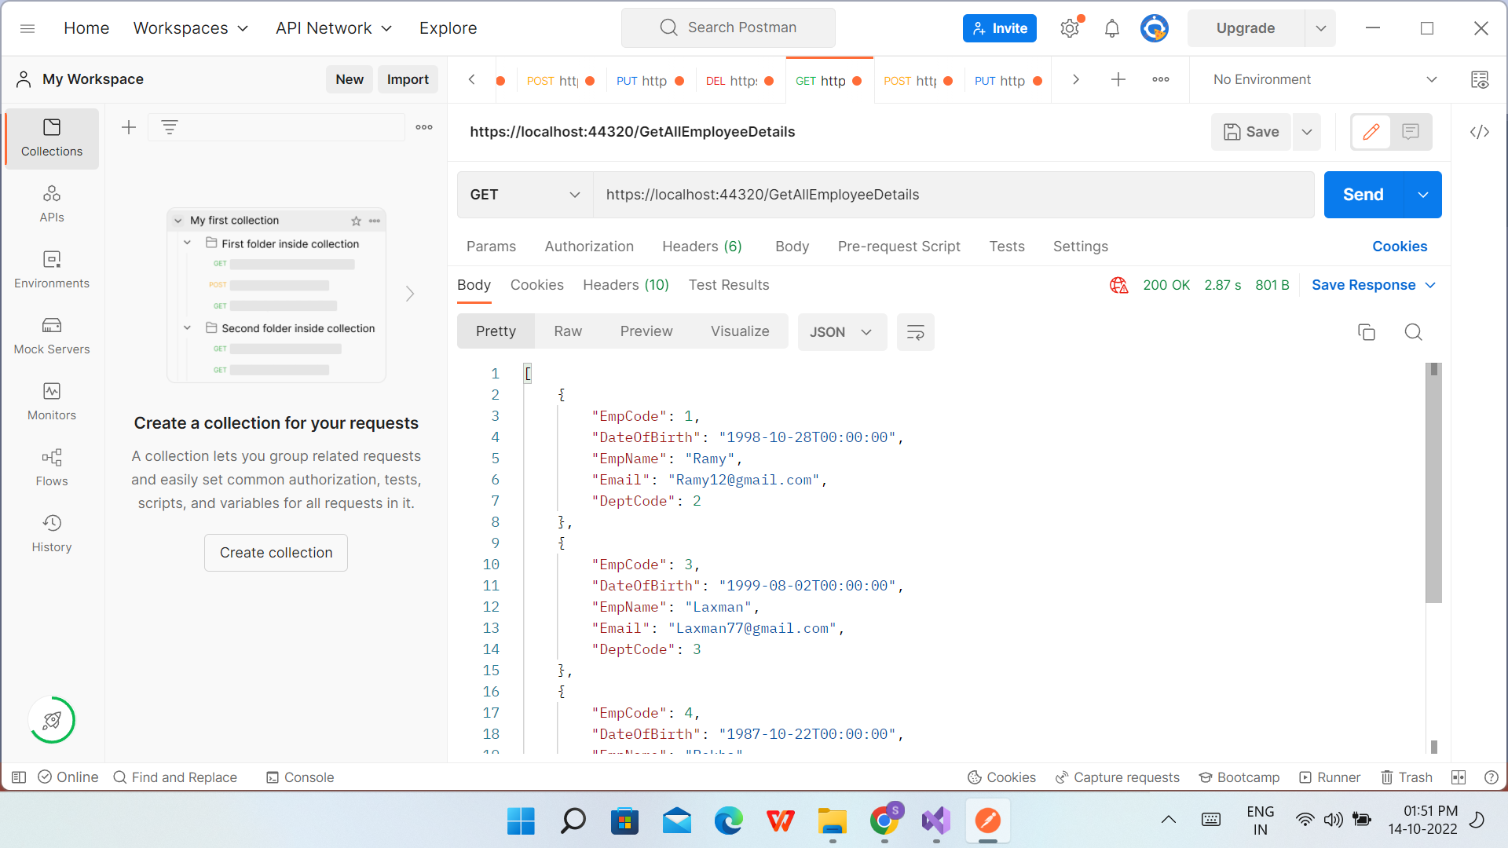

Get Employee Details by Code

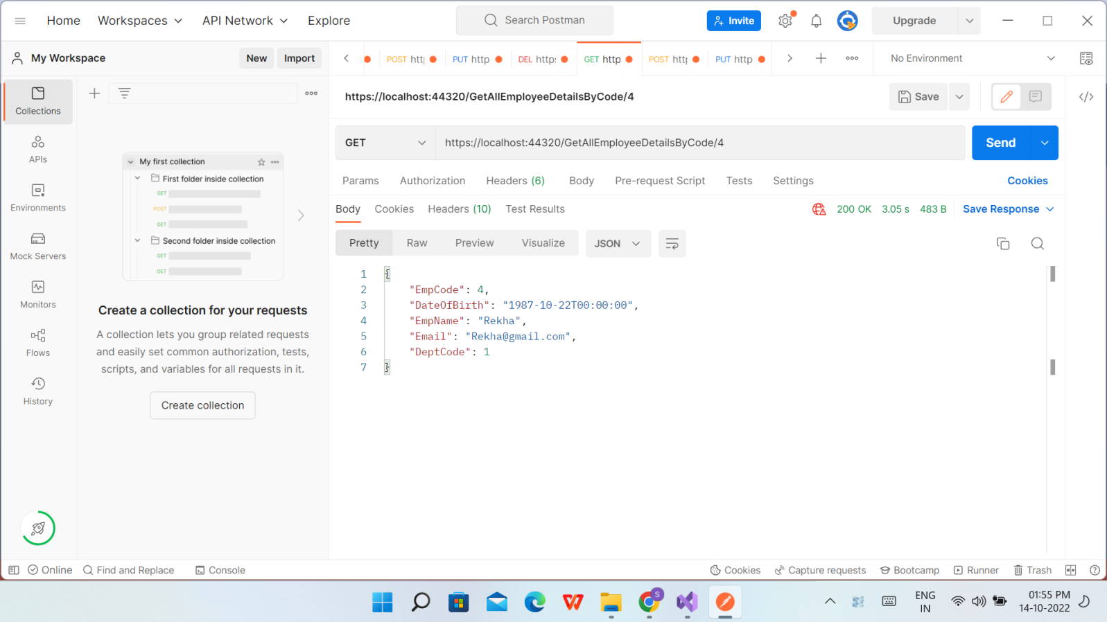

Post - Saving Employee Details

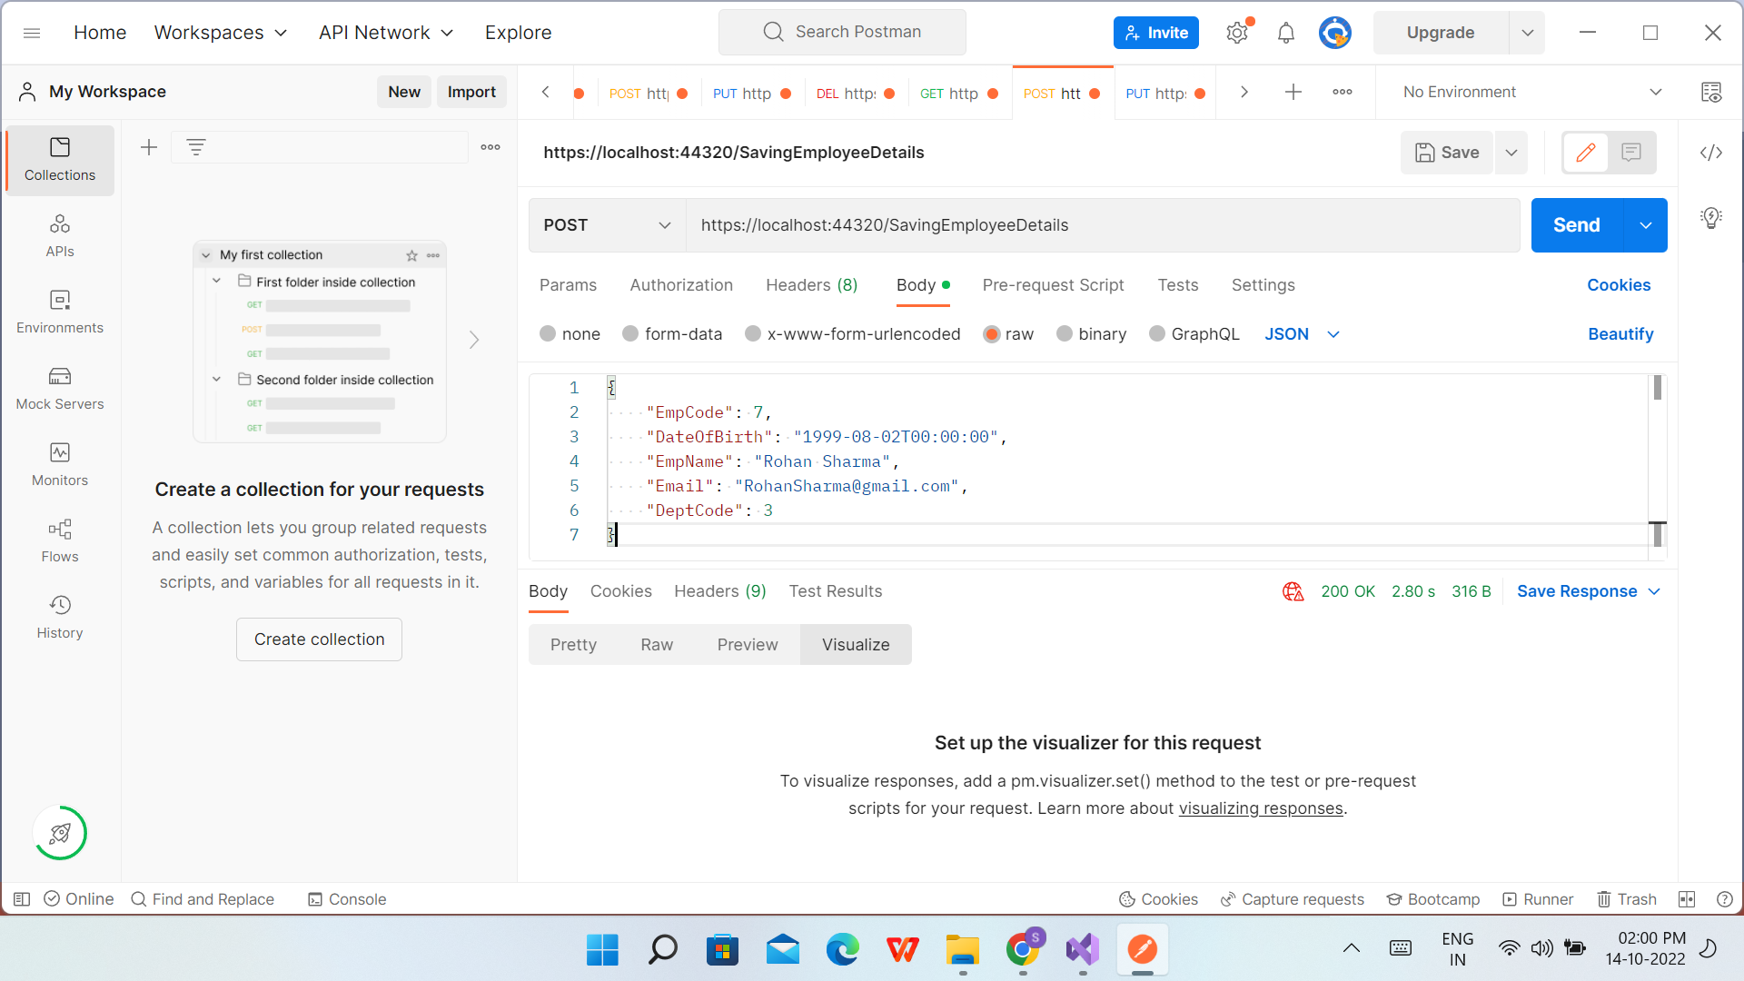

After Post - Saving Employee Details

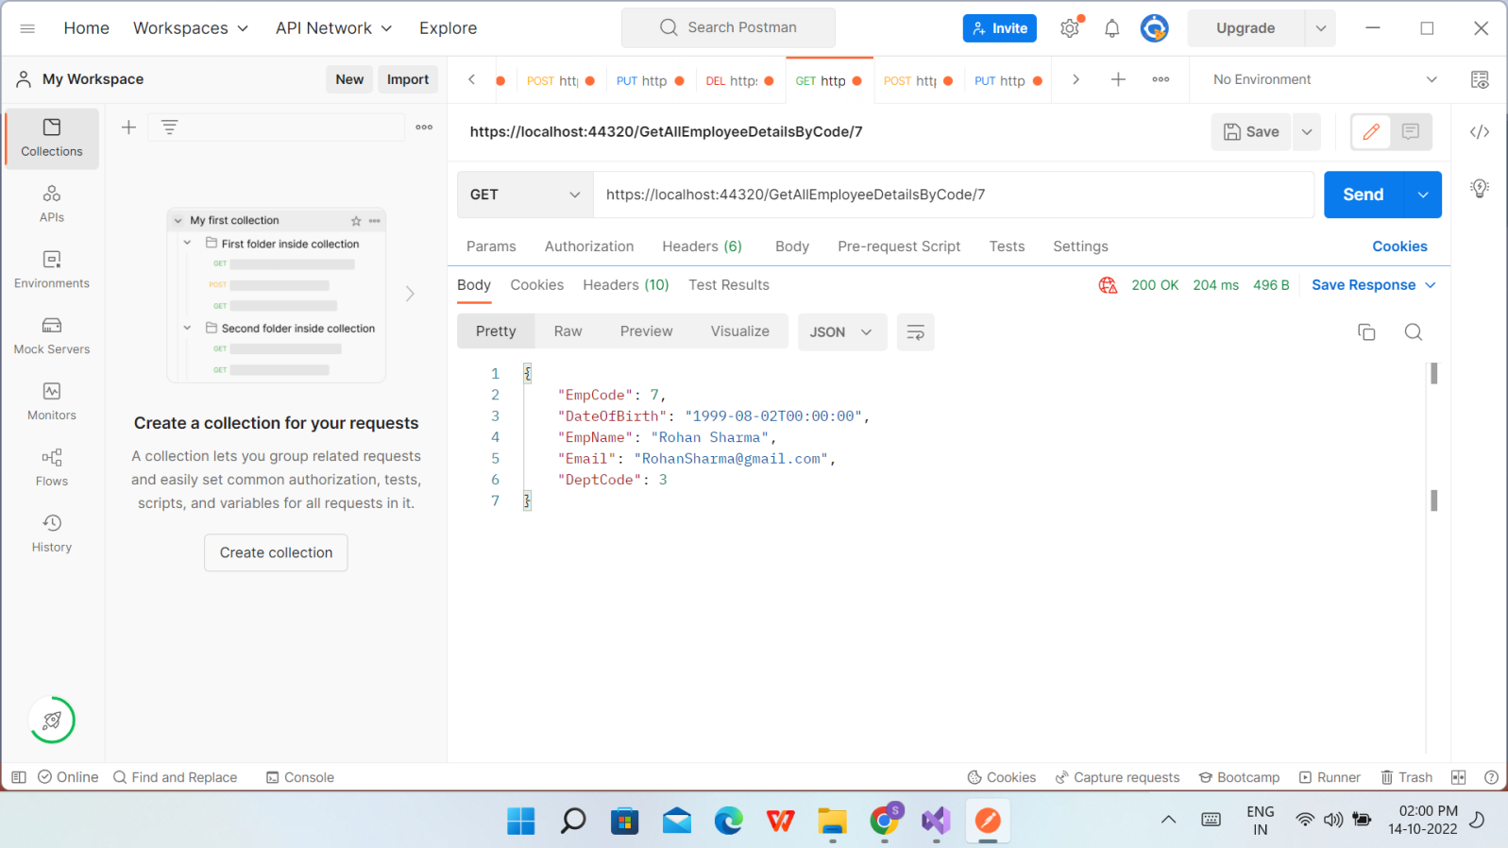

PUT- Update Employee Details
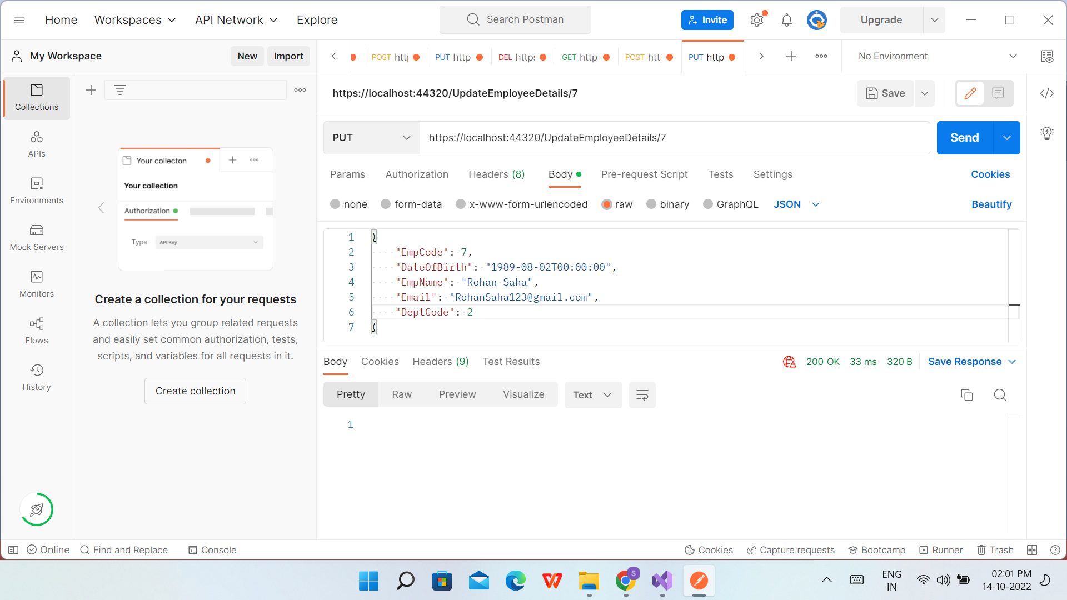

After PUT- Update Employee Details
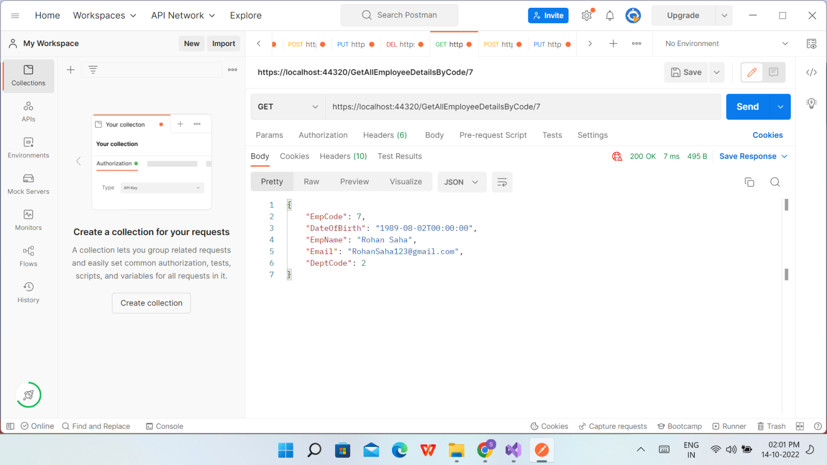

Delete Employee Details
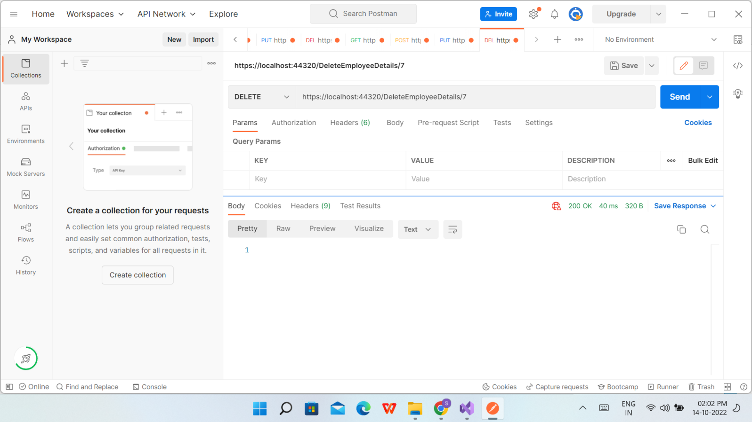

After Delete Employee Details in VS

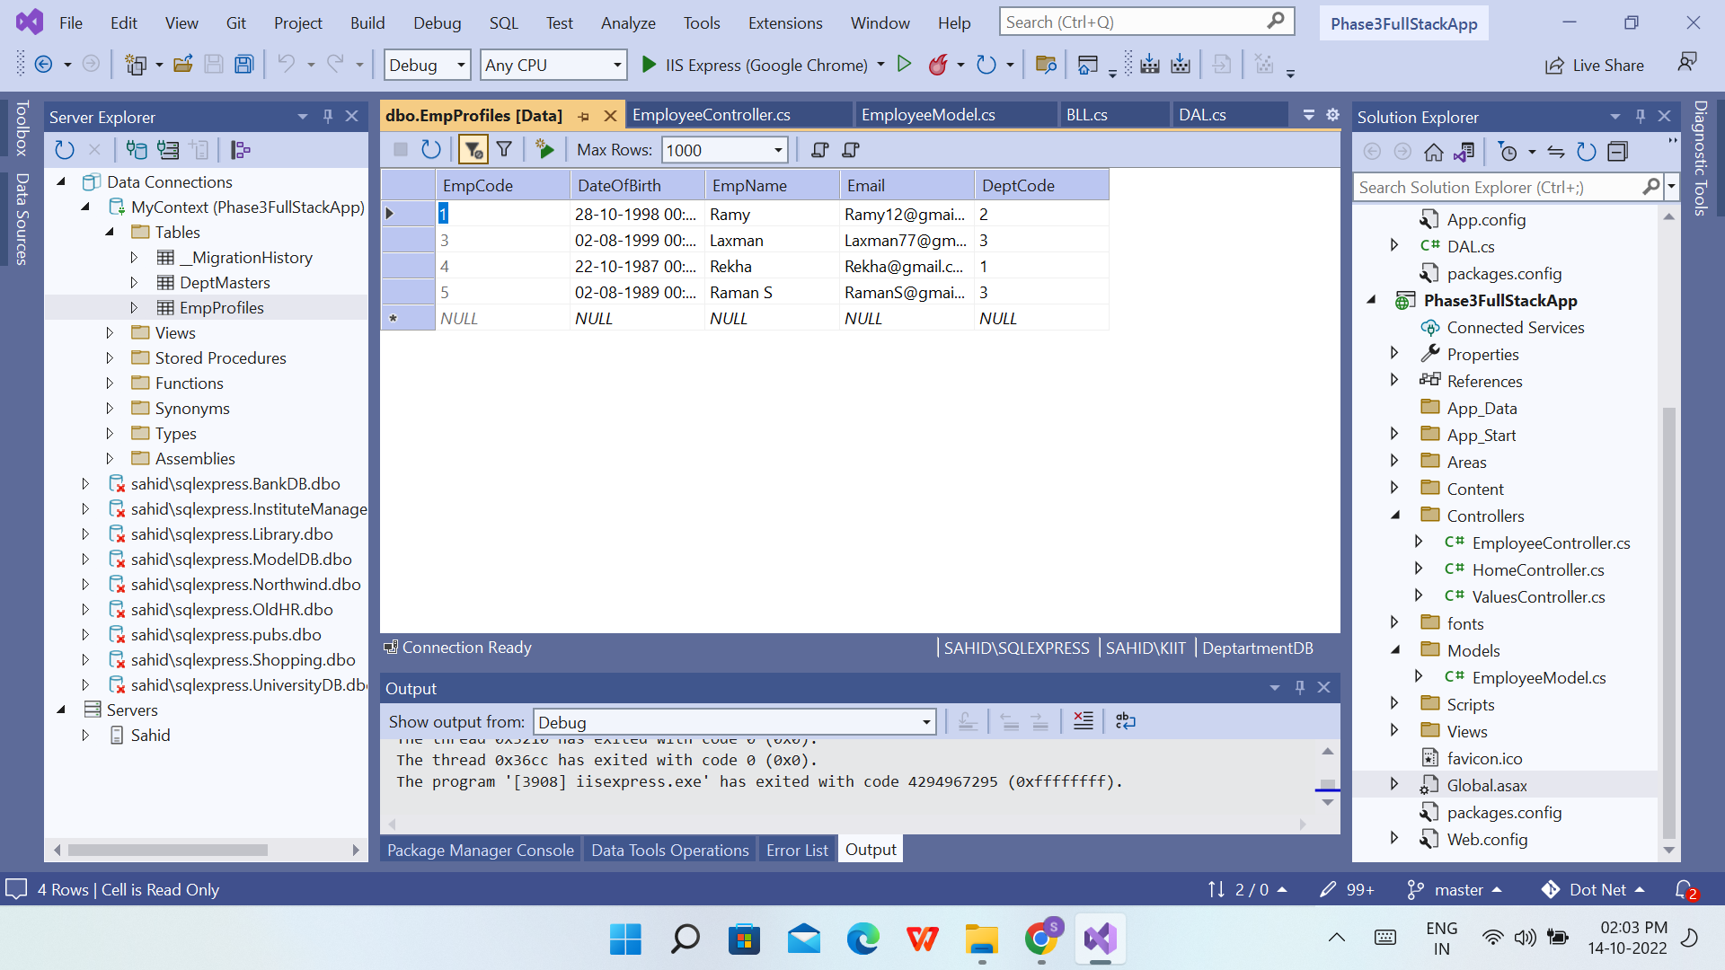

DeptMaster Data
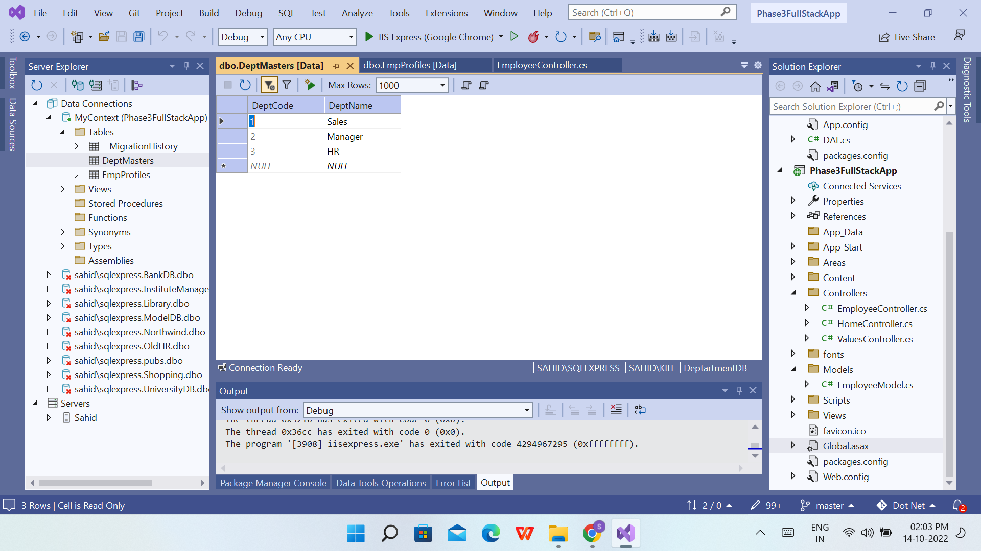

Get All Employee Details in Chrome

